|  |  |
| --- | --- |
| No. of Pages | **3** |
| No. of Questions | 4 |

**Department of Computer Science and Engineering**

**MIDTERM EXAMINATION FALL 2012**

**CSE320/EEE361: Data Communications**

**Total Marks: 60 Time Allowed: 70 minutes**

* Answer ALL **Four (4)** questions.
* Figure in bracket [] next to each question indicates marks for that question.

Question No. 2

1. When you write [www.bracu.ac.bd](http://www.bracu.ac.bd) in your web browser URL, state what roles do HTTP and DNS play in bringing you the web page that you had requested? [5 marks]
2. Your PC uses DHCP, how can you check your IP address and other configurations? DHCP is not recommended for all devices, for example not recommended for Servers, routers etc, why? [4 marks]
3. When an email is being received by your email application which protocol do you use and why? [3 marks]
4. P2P and FTP both are used to transfer files, but how are they different? [3 marks]

## Question No. 3

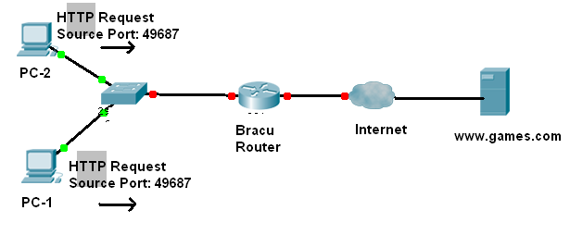

1. Two PCs are sending a HTTP request to the web server [www.games.com](http://www.games.com).
   1. Both HTTP requests have the same port number, can this happen, why?
   2. How will the web server differentiate the request when sending a reply?
   3. What type of port number is “49,687”? What type will be the destination port number? [5 marks]
2. The source host sends segments starting from 1101st to 2600th bytes, each segment is 500 bytes. It has received no acknowledgement from the receiver yet. It uses TCP. [6 marks]
   1. What are the sequence numbers of the segments?
   2. It cannot send anymore, why?
   3. How long will the sender wait?
   4. How can the receiver acknowledge all packets using one acknowledgment packet?
3. TCP is connection oriented. It not only creates a connection but also terminates a connection when done. How does a sender let the receiver know that it is creating a connection and terminating a connection? [4 marks]

##### THE END

**MIDTERM EXAMINATION SUMMER 2012**

**CSE320: Data Communications**

**Extra Sheet**

**Question 1(d)**

|  |  |  |  |  |  |  |  |
| --- | --- | --- | --- | --- | --- | --- | --- |
|  | |  |  |  |  |  |  | | --- | --- | --- | --- | --- | --- | | Frame 1 | |  |  |  |  | | --- | --- | --- | --- | |  |  | |  | | --- | | Data | | | |

|  |  |  |  |  |  |  |  |
| --- | --- | --- | --- | --- | --- | --- | --- |
|  | |  |  |  |  |  |  | | --- | --- | --- | --- | --- | --- | | Frame 2 | |  |  |  |  | | --- | --- | --- | --- | |  |  | |  | | --- | | Data | | | |

|  |  |  |  |  |  |  |  |
| --- | --- | --- | --- | --- | --- | --- | --- |
|  | |  |  |  |  |  |  | | --- | --- | --- | --- | --- | --- | | Frame 3 | |  |  |  |  | | --- | --- | --- | --- | |  |  | |  | | --- | | Data | | | |

**Question No. 4(a):**

|  |  |
| --- | --- |
| IP Address | 200.23.133.117 |
| Subnet Mask | 255.255.224.0 |
| Network Address |  |
| Broadcast Address |  |
| First Usable Host |  |
| Last Usable Host |  |
| Total No. of usable hosts |  |

**Question No. 4(c):**

|  |  |  |
| --- | --- | --- |
| NAT TABLE | | |
| Inside Local Address | Inside Global Address | Outside Global Address |
|  |  |  |
|  |  |  |